________________________________________________________________________
Model: C:\TEMP\UML_Model.mdl

COMPONENT VIEW

Table of Contents

1. Table of Contents 2
2. List of Figures 3
3. Component View Component Package 4
3.1. Main Component Diagram Component Diagram 4
3.2. Client Side Component Package 4
3.2.1. Component Diagram of Client Side Package Component Diagram 4
3.2.2. Flowsheet_Analyser.class Task Body 5
3.2.3. IHM.obj Subprogram Body 5
3.2.4. Pre-Processor.obj Subprogram Body 5
3.2.5. SM_Executive.exe Task Body 5
3.3. Server Side Component Package 5
3.3.1. Component Diagram of Server Side Package Component Diagram 5
3.3.2. Common Services Component Package 6
3.3.2.1. Component Diagram of Common Services Package Component Diagram 6
3.3.2.2. ICapeUtility.idl Package Specification 7
3.3.3. Definition Component Package 7
3.3.3.1. Component Diagram of Definition Package Component Diagram 7
3.3.3.2. ICapeUtilityDefinition.idl Package Specification 8
3.3.4. SMST Component Package 8
3.3.4.1. Component Diagram of SMST Package Component Diagram 8
3.3.4.2. ICapeNumericSMST.idl Package Specification 9
3.3.5. SMST_Application.exe Task Body 9

List of Figures

Figure 1. Main Component Diagram (Component Diagram) 4
Figure 2. Component Diagram of Client Side Package (Component Diagram) 5
Figure 3. Component Diagram of Server Side Package (Component Diagram) 6
Figure 4. Component Diagram of Common Services Package (Component Diagram) 7
Figure 5. Component Diagram of Definition Package (Component Diagram) 8
Figure 6. Component Diagram of SMST Package (Component Diagram) 9

Component View Component Package

Main Component Diagram Component Diagram

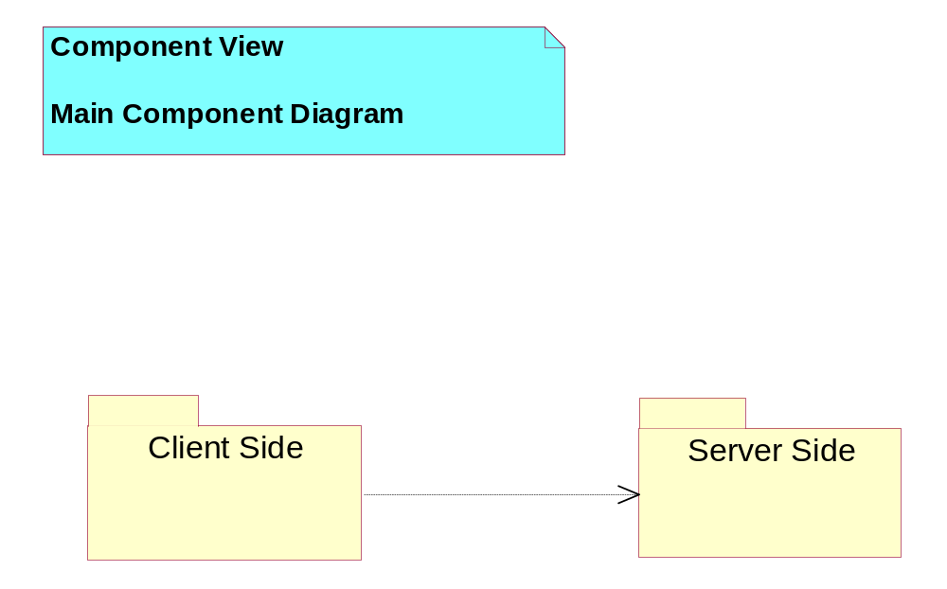
Figure 1. Main Component Diagram (Component Diagram)

Client Side Component Package

Component Diagram of Client Side Package Component Diagram

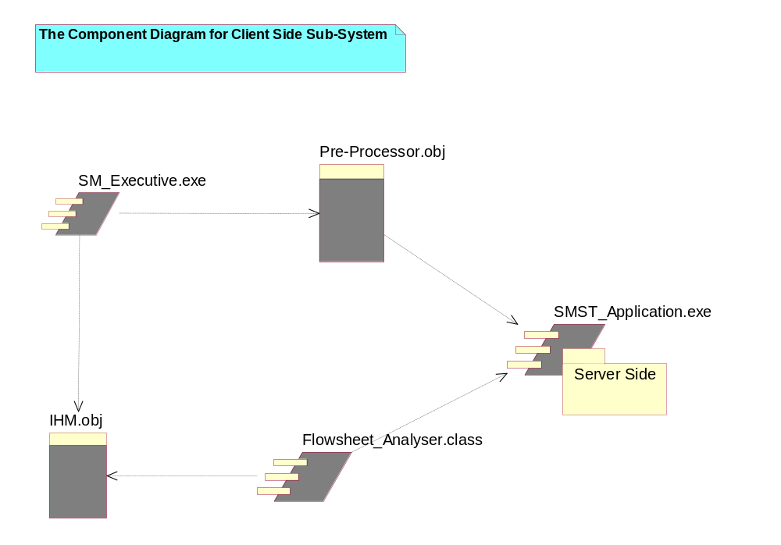
Figure 2. Component Diagram of Client Side Package (Component Diagram)

Flowsheet_Analyser.class Task Body

IHM.obj Subprogram Body

Pre-Processor.obj Subprogram Body

SM_Executive.exe Task Body

Server Side Component Package

Component Diagram of Server Side Package Component Diagram

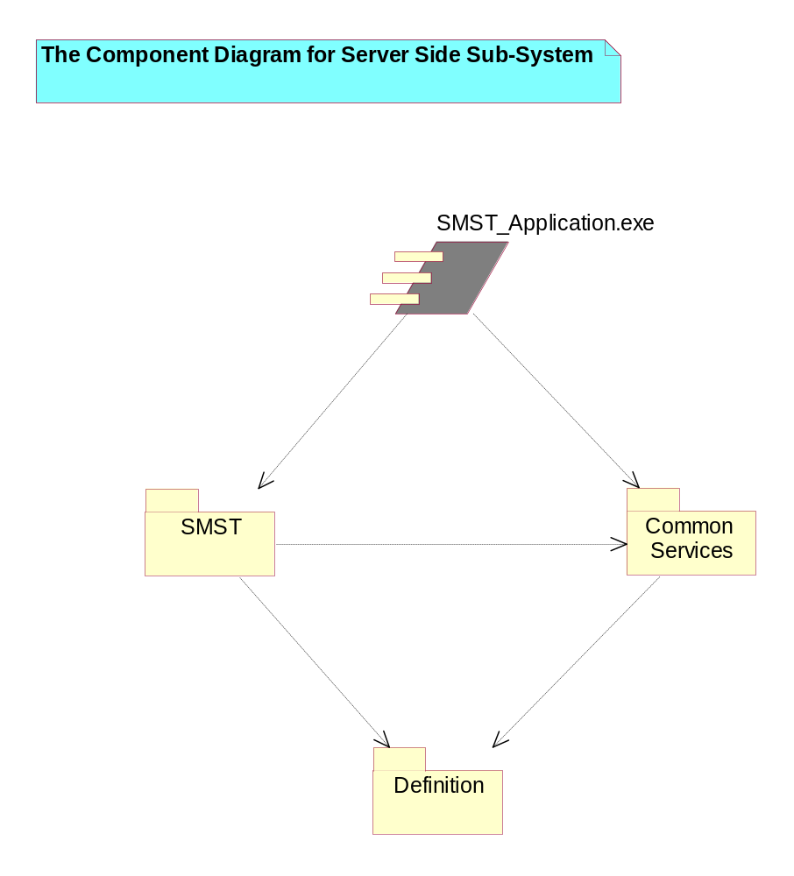
Figure 3. Component Diagram of Server Side Package (Component Diagram)

Common Services Component Package

Component Diagram of Common Services Package Component Diagram

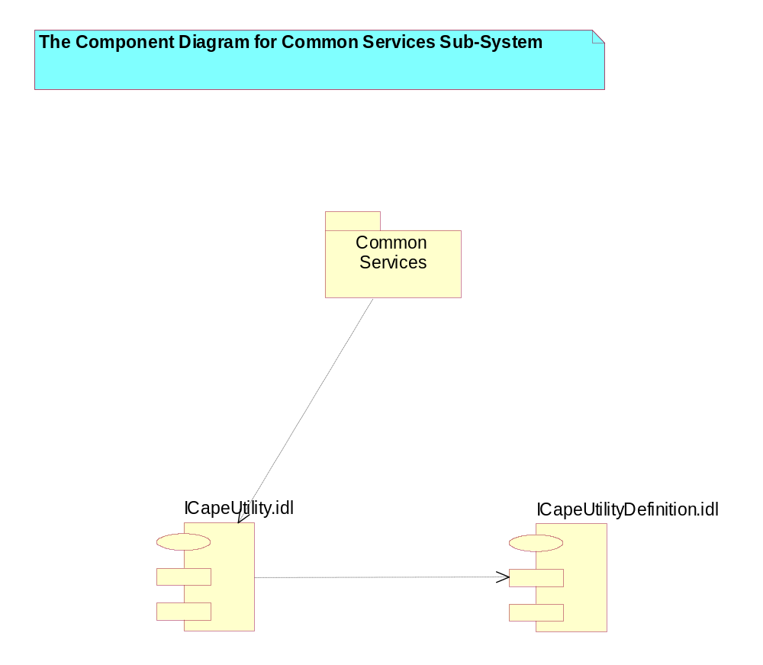
Figure 4. Component Diagram of Common Services Package (Component Diagram)

ICapeUtility.idl Package Specification

Definition Component Package

Component Diagram of Definition Package Component Diagram

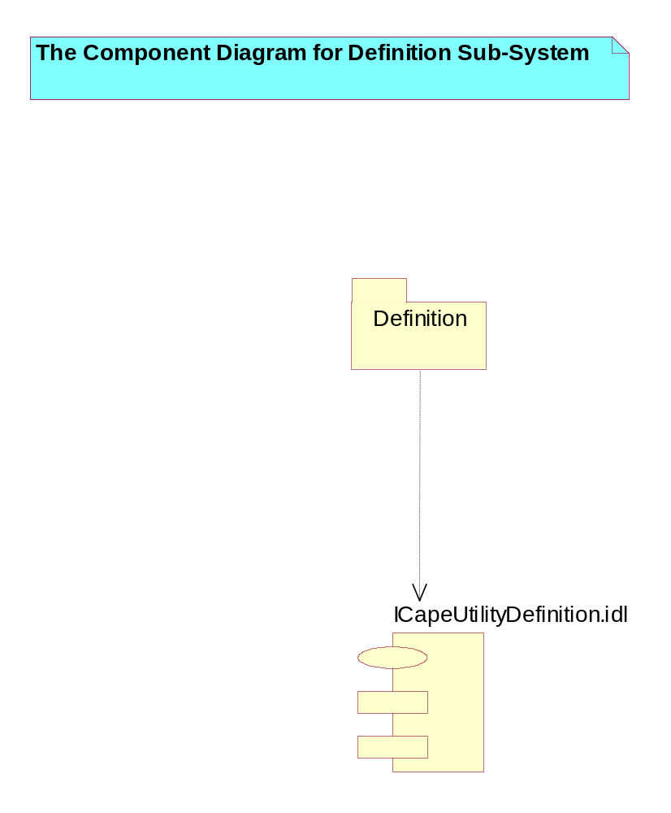
Figure 5. Component Diagram of Definition Package (Component Diagram)

ICapeUtilityDefinition.idl Package Specification

SMST Component Package

Component Diagram of SMST Package Component Diagram

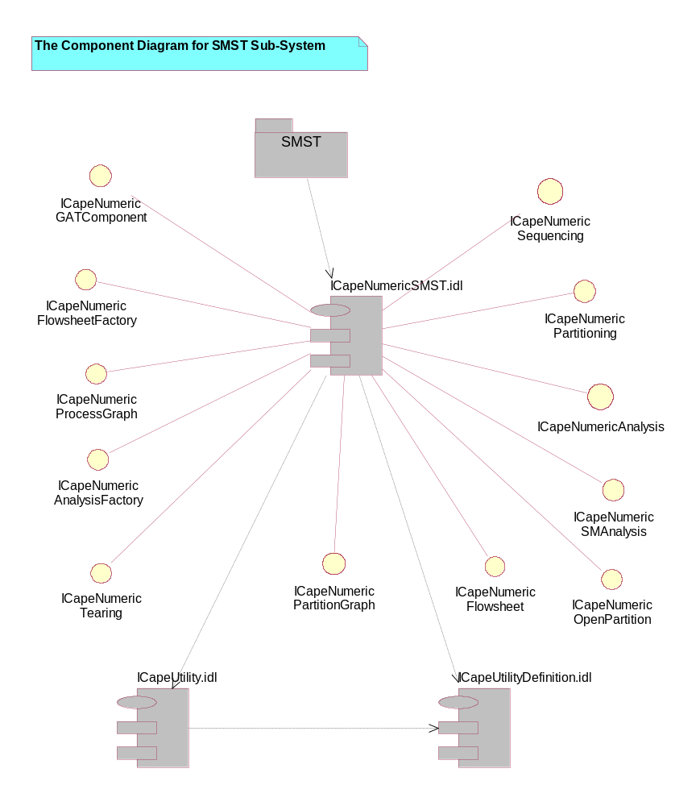
Figure 6. Component Diagram of SMST Package (Component Diagram)

ICapeNumericSMST.idl Package Specification

SMST_Application.exe Task Body

